Greetings, Family and Friends of Class of 2025!

As the commencement ceremony approaches at the end of this spring, the University of Lynchburg is thrilled to offer you the ultimate commencement experience!

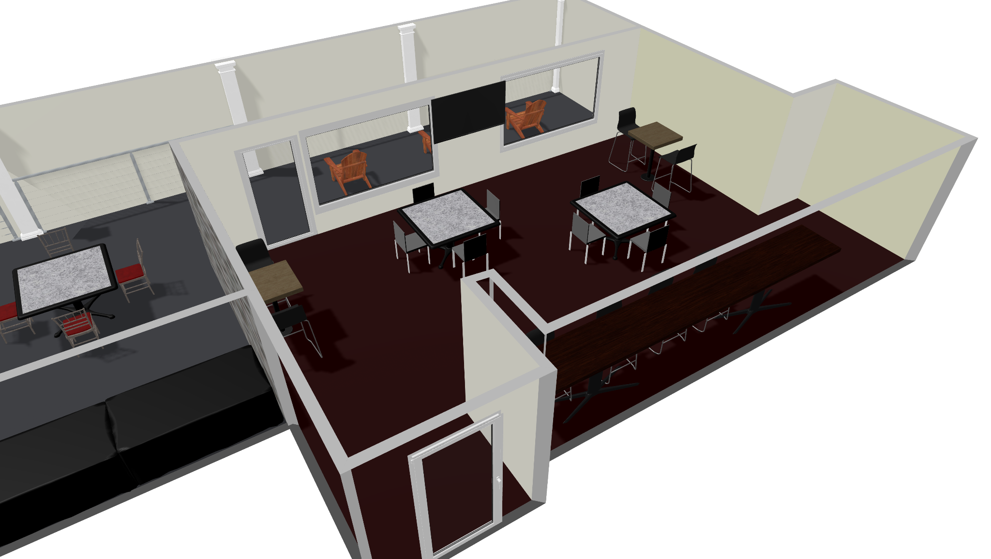
We present to you an exclusive opportunity to view the commencement ceremony from the unparalleled comfort of the four balconies at Westover Hall that overlooks the Shellenberger Field.

We have two VIP Balcony Packages for you to choose from and they come with the following perks:

Westover Basic Lounge - $1,500
- 4 parking spaces at the adjacent lot
- Coffee - Pump pot (regular and de-cafe) 2.5
- Iced Water 2.5
- Medium fruit and vegetable tray with dips

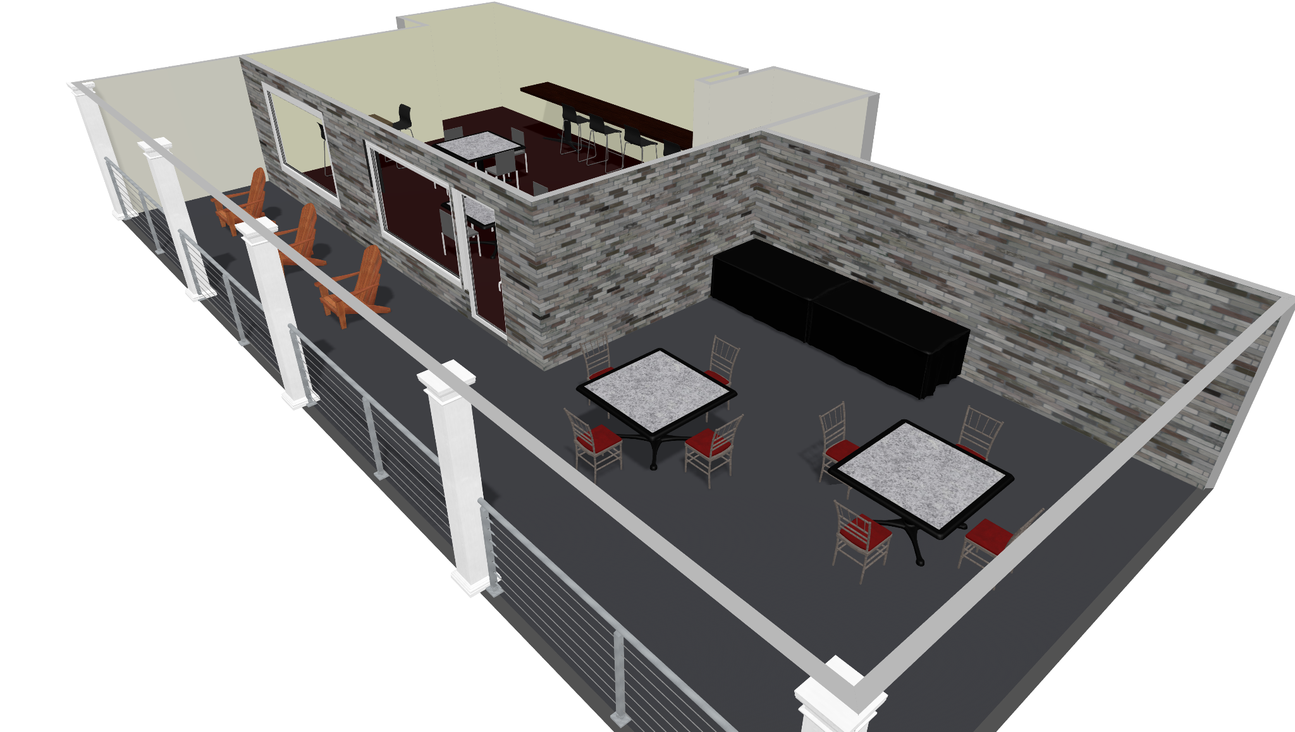

Westover Sky Lounge - $2,000
- 4 parking spaces at the adjacent lot
- Coffee - Pump pot (regular and de-cafe) 2.5
- Iced Water 2.5
- Medium Fruit and vegetable tray with dips
- Kitchen and private bathroom

Both packages will grant you access to the lounge from 7:00 a.m. - 1:00 p.m. and the maximum number of guests allowed is 15 people. You are also welcome to bring your own food in addition to the complimentary fruit and vegetable tray. However, please note that you are not allowed to bring alcohol into the premises.

You may also opt to order more food from the University of Lynchburg’s very own Hopwood & LaRue Catering and Events Menu and/or add a cash bar to your package.

To register and reserve your spaces, as well as customize your package with additional food or drinks, please contact Joshua Brown, Manager of Catering and Events, at 434.544.8271 or email him at hopwoodlarue@lynchburg.edu. Reservation is granted on a first come, first served basis.

The deadline for 10% down payment to reserve these spaces is May 2, 2025. Payment of the rest is expected on the day of the ceremony. You may cancel your reservation and get a refund only in the event of inclement weather.

Please note that there are only two available Westover Basic Lounges and two Westover Sky Lounges. Hurry and secure your spot for an unforgettable day!

See you soon!

Sincerely,
The Commencement Committee
University of Lynchburg

