Reconstruction Choices

Scarlett Rebuilds Tara
Introduction: Scarlett O’Hara, a beautiful southern belle is more than a pretty face. She is a strong-willed, resourceful, deceptive and, at times, a spoiled make-it-happen business woman. Life during and after the Civil War brought difficulties, struggles, and disappointments. During reconstruction, she vowed to not lose her beloved Tara, the plantation where she grew up. The love for her family’s plantation and her selfish behavior cost her much: A relationship with her sister, her reputation in social circles, and a true love. Did the benefits outweigh the costs?

Note: Successful completion of this lesson is not dependent on having read the novel.

Time Required: 40-45 minutes
Grade Level: 6-12
Objectives:
- The student will be introduced to the concepts of costs and benefits.
- The student will complete a group activity based on a fictional choice by using a Cost-Benefit Analysis Chart.
- The student will analysis a historical decision based on the costs and benefits of the historical situation.
- The student will make an independent decision based on the costs and benefits of a fictional situation.
- The student will complete an information form related to Reconstruction after the Civil War.
Materials:
- Visual 1- Tara (Pre- and Post- Civil War)
- Visual 2- Cost-Benefit Analysis of Economics Choices – FICTIONAL
- Visual 3- FICTIONAL Choice Card (Scarlett O’Hara)
- Visual 4 – Cost-Benefit Analysis of Economics Choices – FICTIONAL (answers)
- Fictional Choice Cards- Printed on cardstock
- Copy(s) of Activity 3: Cost-Benefit Analysis of Economics Choices – FICTIONAL
- Copy(s) of Activity 4: Cost-Benefit Analysis of Economic Choices – HISTORICAL
- Copy(s) of Activity 5: Cost-Benefit Analysis of Economic Choices – PRESENT
- Copy(s) of Activity 6: Reconstruction Legacies
- Optional - Copy(s) of Gone With the Wind by Margaret Mitchell for student reference
- Optional – 9x12 clasp envelopes for constructing a Cost-Benefit foldable (Extension)

National Standards
Standard 1: Scarcity - Productive resources are limited. Therefore, people cannot have all the goods and services they want; as a result they must choose some things and give up others.
Standard 2: Decision Making - Effective decision making requires comparing the additional costs of alternatives with the additional benefits. Many choices involve doing a little more or a little less of something: few choices are “all or nothing” decisions
Virginia Standards of Learning- Social Studies
USI.1h  USII.1h  CE.1 | The student will demonstrate skills for historical thinking, geographical analysis, economic decision making, and responsible citizenship by using a decision-making model to identify the costs and benefits of a specific choice made.
GOVT.1h | The student will demonstrate skills for historical thinking, geographical analysis, economic decision making, and responsible citizenship by using a decision-making model to analyze the costs and benefits of a specific choice, considering incentives and possible consequences.
USII.3a | The student will demonstrate knowledge of the effects of Reconstruction on American life by analyzing the impact of the 13th, 14th, and 15th Amendments to the Constitution of the United States.
USII.3b | The student will apply social science skills to understand the effects of Reconstruction on American life by describing the impact of Reconstruction policies on the South and North.
USII.3c | The student will apply social science skills to understand the effects of Reconstruction on American life by describing the legacies of Abraham Lincoln, Robert E. Lee, and Frederick Douglass.
VUS.7d | The student will apply social science skills to understand the Civil War and Reconstruction eras and their significance as major turning points in American history by evaluating postwar Reconstruction plans presented by key leaders of the Civil War.
VUS.7f | The student will demonstrate knowledge of the Civil War and Reconstruction Era and their importance as major turning points in American history by explaining postwar contributions of key leaders of the Civil War.
Virginia Standards of Learning- Economics/Personal Finance
EPF.1a | The student will demonstrate knowledge of basic economic concepts and structures by describing how consumers, businesses, and government decision makers face scarcity of resources and must make trade-offs and incur opportunity costs.
EPF.1b | The student will demonstrate knowledge of basic economic concepts and structures by explaining that choices often have long-term unintended consequences.
EPF.1c | The student will demonstrate knowledge of basic economic concepts and structures by describing how effective decision making requires comparing the additional costs (marginal costs) and additional benefits (marginal benefits);
Economic Concepts
- Benefit – reward gained from an action or activity.
- Choice - takes place whenever someone makes a personal decision to use limited resources.
- Cost – something given up when a choice is made
- Cost-benefit analysis –an analysis of the cost effectiveness of an alternative in order to see whether the benefits outweigh the costs. A decision will be made when the benefits outweigh the costs.
- Incentive- an expected reward or penalty that motivates a person to take an action.
- Intended Consequence – A result or effect of an action or decision that was expected. Can be positive or negative.
- Opportunity cost – that which is given up when a choice is made. When deciding how to spend a resource it is one’s second best alternative; the alternative given up.
- Scarcity – the condition of limited resources. Because resources are limited, people must make choices
- Reconstruction - The period after the Civil War in which the states formerly part of the Confederacy were brought back into the United States. During Reconstruction, the South was divided into military districts for the supervision of elections to set up new state governments.
- Untended Consequence – A result or effect of an action or decision that was unexpected. Can be positive or negative.

Procedure:
- Prepare and collect materials prior to class.
- Introduce the lesson by asking the students if they are familiar with Gone With the Wind by Margaret Mitchell. (Successful completion of this lesson is not dependent on having read the novel.)
- For those students who have not read Gone With the Wind, share the following background information from the novel. (If time allows, encourage students who have read the book to share other details with the class.)
  - The main heroine in this Civil War novel is Scarlett O’Hara. Scarlett makes multiple hard choices based on her love for Ashley Wilkes, lack of money, and a desire to survive.
  - Scarlett generally concerns herself only with her wants and desires. She can usually come up with a scheme to get what she wants.
  - During the Civil War, Scarlett promises Ashley to stay with his wife, Melanie in Atlanta who is expecting his child. Scarlett finds herself becoming loyal to Melanie even though, she would rather be the one married to Ashley. In return, Melanie becomes a faithful friend to Scarlett.
  - When Atlanta is being taken over and set a blaze by the Union army, Scarlett determines it is time to escape a city under seize. Melanie has just given birth, and it is time to escape Atlanta.
  - Scarlett enlists the help of Rhett Butler to flee Atlanta. Rhett helps until he decides to join the confederate army. Now, it is up to Scarlett to navigate a horse and buggy out of danger with a sick new mother and a newborn.
  - They arrive at Tara, Scarlett’s family plantation, to find destruction. Scarlett’s mother, Ellen is dead. Her sisters are sick with Typhoid Fever. She is caring for Melanie and her newborn child. Gerald, her father has gone mad.
  - Scarlett’s will to survive takes over. She manages to protect Tara from ultimate destruction by killing a union solider and putting out a fire that has been set.
  - After the Civil War ends, a former employee of Tara, Jonas Wilkerson begins working for the Freedman’s Bureau. He influences the government to increase taxes on Tara as a means to purchase Tara for his own.
  - Scarlett vows to not let that happen. She devises a plan to save Tara which involves marrying her sister’s suitor, Frank Kennedy. Frank pays the taxes on Tara. Frank, along with many other Southern loyalists, join the Ku Klux Klan.
  - Frank is killed. Scarlett becomes a ruthless businesswoman. She marries Rhett Butler. The marriage is very tumultuous. By the time Scarlett realizes she is truly in love with Rhett, it is too late.
  - The novel ends with Scarlett vowing to get Rhett back. She will, “Think of it tomorrow . . . After all, tomorrow is another day.”

- To help students visualize Scarlett’s love for pre-war Tara and destruction caused by the war, show visual 1.
- Discuss decision making by using a Cost/Benefit Analysis. Define the following terms:
  - Cost-benefit analysis –an analysis of the cost effectiveness of an alternative in order to see whether the benefits outweigh the costs. A decision will be made when the benefits outweigh the costs.
  - Benefit – reward gained from an action or activity.
  - Cost – something given up when a choice is made
  - Choice - takes place whenever someone makes a personal decision to use limited resources.
  - Intended Consequence – A result or effect of an action or decision that was expected. Can be positive or negative.
  - Untended Consequence – A result or effect of an action or decision that was unexpected. Can be positive or negative.
- Display Visual 2 and discuss the outline of using a Cost/Benefit Analysis to solve a “FICTIONAL” decision from Gone With the Wind.
- Next tell students, they will use the Cost/Benefit Analysis to explore Scarlett’s decision of how to pay the increased taxes on Tara. Display Visual 3 – FICTIONAL Choice Card. Tell students this is one alternative that Scarlett had in making a decision about paying Tara’s taxes. Using this Choice Card, use the Cost/Benefit Analysis to solve this “FICTIONAL” decision. (See Visual 5).
- Divide students into groups and distribute one choice card from Activity 1. Have students use the Cost/Benefit Analysis to solve their group’s “FICTIONAL” alternative for Scarlett’s dilemma.
- Allow the students in each group to analysis the group’s alternative. Ask each group to share with the class the costs, benefits, intended consequences, and/or unintended consequences.
- Discuss historical events of the Civil War Reconstruction era. Distribute “HISTORICAL” choice cards and a Cost/Benefit Analysis – HISTORICAL to each group. Have the group analysis this historical decision, then report their findings to the class.
- Next, tell students that a Cost/Benefit Analysis is a useful tool for individuals, groups, businesses, and governments to use when making decisions. All choices have costs and benefits. Encourage students to use Activity 5: Cost-Benefit Analysis of Economic Choices – PRESENT to make a current decision on their own. (For example: To get an afterschool job or not; to learn a new language or not; to purchase a smart phone or not)
- Conclude, the lesson by distributing Activity 6: Reconstruction Legacies. Students can complete the activity individually in class or for homework.
Extension Activity:
- Using a 9x12 manila envelope, students can create a Cost/Benefits foldable as an aid in exploring the cost and benefits of an alternative. See examples below:

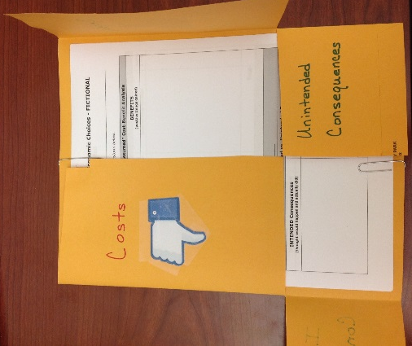
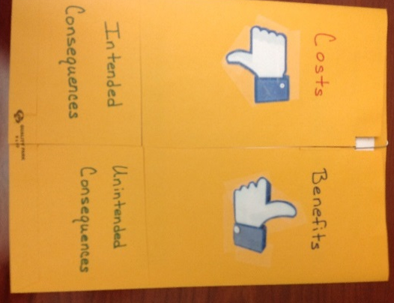

Visual 1
Tara (Pre- Civil War)
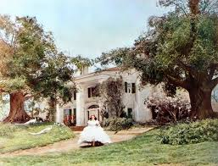

Tara (Post- Civil War)
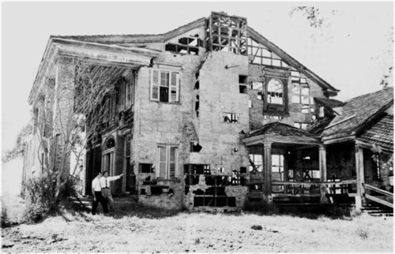

Visual 2
Cost-Benefit Analysis of Economic Choices - FICTIONAL
Fictional Choice:
NOTE: Consider short-term and long-term as you brainstorm below.
BEFORE CHOICE WAS MADE – “Assumed” Cost-Benefit Analysis

COSTS  (things you give up) | Scale  1 – 5 |  | BENEFITS  (positive things you gain) | Scale  1 – 5
Total |  |  | Total
What choice did the character make? ___________________________________________

CHOICE OUTCOME – Actual Intended vs. Unintended Consequences

INTENDED Consequences  (thought would happen and actually did) |  | UNINTENDED Consequences  (did not know would happen)

Visual 3
FICTIONAL Choice Card
Scarlett O’Hara
Betray your sister and marry her beau, Frank Kennedy. Frank is a wealthy general store owner who want to purchase a saw mill. After, marriage encourage him to pay the $300 in taxes.

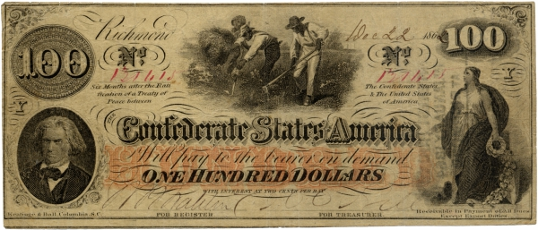

Activity 1
FICTIONAL Choice Cards
Scarlett O’Hara
Seduce Rhett Butler so that he will give $300 to pay taxes for Tara.
Refuse to pay the $300 in taxes and sell Tara to Jonas Wilkerson, a former employee at Tara.
Refuse to pay the $300 in taxes. Lock the doors and refuse to leave Tara.
Get a job cleaning house to earn $300 to pay the required taxes for Tara.

Activity 2
HISTORICAL Choice Cards
Reconstruction
Frederick Douglass advocated for the passage of the 14th and 15th Amendments.
Robert E. Lee urged Southerners to reconcile and rejoin the United States following the end of the Civil War.
On December 8, 1863, President Abraham Lincoln offered his conciliatory plan for reunification of the United States with his Proclamation of Amnesty and Reconstruction.
On July 28, 1868, the 14th amendment was ratified by the necessary 28 of the 37 States, and became part of the supreme law of the land.
The 14th amendment prohibits states from denying equal rights under the law to any American.
Passed by Congress February 26, 1869, and ratified February 3, 1870, the 15th amendment granted voting rights regardless of “race, color, or previous condition of servitude.”

Visual 4
Cost-Benefit Analysis of Economic Choices – FICTIONAL
Weighted
Fictional Choice: Betray your sister and marry Frank Kennedy, a general store owner. Then he will pay the $300 in taxes.
NOTE: Consider short-term and long-term as you brainstorm below.
SCALE: 1=not very important 5=very important
BEFORE CHOICE WAS MADE – “Assumed” Cost-Benefit Analysis

COSTS  (things you give up) | Scale  1 – 5 |  | BENEFITS  (positive things you gain) | Scale  1 – 5
Loose relationship with sister.  You are giving up the chance to marry for love.  Ruin your social reputation in Atlanta. | 1  2  1 |  | Receive $300 from Frank to pay the taxes on Tara.  Frank is a business owner with a means of earning an income to provide a means of survival. | 5  5
Total |  |  | Total
What choice did the character make? To Marry Frank Kennedy for money.

CHOICE OUTCOME – Actual Intended vs. Unintended Consequences

INTENDED Consequences  (thought would happen and actually did) |  | UNINTENDED Consequences  (did not know would happen)
Received $300 from Frank to pay taxes on Tara.  Paid taxes and saved Tara from being sold. |  | Frank is not a good businessman. He does not require people to pay their debts to him and/or his business on time.  Scarlett becomes a ruthless business woman and takes over managing the store and sawmill.  Frank joins the KKK and is shot during an attack.

Activity 3
Cost-Benefit Analysis of Economic Choices – FICTIONAL
Weighted
Fictional Choice:
NOTE: Consider short-term and long-term as you brainstorm below.
SCALE: 1=not very important 5=very important
BEFORE CHOICE WAS MADE – “Assumed” Cost-Benefit Analysis

COSTS  (things you give up) | Scale  1 – 5 |  | BENEFITS  (positive things you gain) | Scale  1 – 5
Total |  |  | Total
What choice did the character make? ___________________________________________

CHOICE OUTCOME – Actual Intended vs. Unintended Consequences

INTENDED Consequences  (thought would happen and actually did) |  | UNINTENDED Consequences  (did not know would happen)

Activity 4
Cost-Benefit Analysis of Economic Choices – PAST
Weighted
Historical Choice:
NOTE: Consider short-term and long-term as you brainstorm below.
SCALE: 1=not very important 5=very important
BEFORE CHOICE WAS MADE – “Assumed” Cost-Benefit Analysis

COSTS  (things you give up) | Scale  1 – 5 |  | BENEFITS  (positive things you gain) | Scale  1 – 5
Total |  |  | Total
What choice was made? ___________________________________________

CHOICE OUTCOME – Actual Intended vs. Unintended Consequences

INTENDED Consequences  (thought would happen and actually did) |  | UNINTENDED Consequences  (did not know would happen)

Activity 5
Cost-Benefit Analysis of Economic Choices – PRESENT
Weighted

Today’s Choice: _
NOTE: Consider short-term and long-term as you brainstorm below.
Cost-Benefit Analysis

COSTS  (things you give up) | Scale  1 – 5 | BENEFITS  (positive things you gain) | Scale  1 – 5
Total |  | Total
What will you do? ____________________________________________________________

Activity 6
Reconstruction Legacies
Scarlett O’Hara’s  Reconstruction Plan | Abraham Lincoln’s  Reunification Plan | Robert E. Lee’s  contribution to Reconstruction | Frederick Douglass’  Reconstruction Impact
Occupation(s): ______________________________  ______________________________  Reconstruction Plan: ______________________________  ______________________________  ______________________________  Scarlett’s Faithful Friend:  ______________________________  ______________________________  ______________________________  Impact of Reconstruction on Atlanta:  ______________________________  ______________________________  ______________________________  ______________________________  ______________________________  ______________________________  ______________________________  ______________________________  Famous Quote:  ______________________________  ______________________________  ______________________________ | Occupation(s): ______________________________  ______________________________  Reconstruction Plan:  1. ____________________________  ______________________________  ______________________________  ______________________________  2. ____________________________  ______________________________  ______________________________  ______________________________  3. ____________________________  ______________________________  ______________________________  ______________________________  Famous Speech and/or Quote:  ______________________________  ______________________________  ______________________________  ______________________________  ______________________________  ______________________________  ______________________________  ______________________________  ______________________________  ______________________________  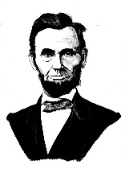 | Occupation(s): ______________________________  ______________________________  His Advice to the South after the Civil War: ______________________________  ______________________________  ______________________________  His Wife’s Home in Northern Virginia is now the present day location of this Famous Cemetery:  ______________________________  ______________________________  After the Civil War, He Served as President to What College/University:  ______________________________  ______________________________  ______________________________  He Emphasized the importance of ___________ to the Nation’s Future.  Famous Quote: ______________________________  ______________________________  ______________________________  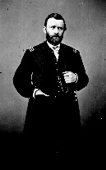 | Occupation(s): ______________________________  ______________________________  Advocated for full ______________ for African Americans.  14th Amendment:  ______________________________  ______________________________  ______________________________  ______________________________  15th Amendment:  ______________________________  ______________________________  ______________________________  ______________________________  Life’s great accomplishments:  ______________________________  ______________________________  ______________________________  ______________________________  ______________________________  Famous Quote:  ______________________________  ______________________________  ______________________________  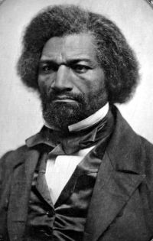
Activity 6
Reconstruction Legacies (ANSWERS)
Scarlett O’Hara’s  Reconstruction Plan | Abraham Lincoln’s  Reunification Plan | Robert E. Lee’s  contribution to Reconstruction | Frederick Douglass’  Reconstruction Impact
Occupation(s): Daughter, Wife, Mother, Plantation Manager, Mill Owner, Cotton Picker  Reconstruction Plan:  1. To rebuild Tara, her family’s plantation.  2. To obtain $300 to pay for Tara’s taxes.  3. To survive.  Scarlett’s Faithful Friend:  Melanie, wife of Ashley Wilkes  Impact of Reconstruction on Atlanta:  Atlanta began to be rebuilt. Scarlett’s husband, Frank owned a successful mill which helped Atlanta’s rebuilding efforts. Several former confederate soldiers rebelled, by starting a Ku Klux Klan local group. Many did not like northern “carpetbaggers”.  A Famous Quote:  “I’m never going to be hungry again.”  “I’ll think of it tomorrow.”  “After all, tomorrow is another day.” | Occupation(s): 16th President of the United States of America  Reconstruction Plan:  1. Allows for a full pardon for and restoration of property to all engaged in the rebellion with the exception of the highest Confederate officials and military leaders.  2. Allowed for a new state government to be formed with 10% of the eligible voters had taken an oath of allegiance of the United States.  3. The Southern states admitted in this fashion were encouraged to enact plans to deal with the freed slaves so long as their freedom was not compromised.  A Famous Speech and/or Quote:  The Gettysburg Address (1863)  Four score and seven years ago our fathers brought forth, upon this continent, a new nation, conceived in liberty, and dedicated to the proposition that "all men are created equal" | Occupation(s):  Commander-in-Chief of all Confederate Armies  His Advice to the South after the Civil War:  He urged Southerners to reconcile with Northerners at the end of the war and reunite as Americans when some wanted to continue to fight.  His Wife’s Home in Northern Virginia is now the present day location of this Famous Cemetery:  Arlington National Cemetery  After the Civil War, He Served as President to What College/University:  Washington College, which is now known as Washington and Lee University in Lexington, VA.  He Emphasized the importance of education to the Nation’s Future.  A Famous Quote:  “The education of a man is never complete until he dies.” | Occupation(s): Former slave, Abolitionist, Served as ambassador to Haiti and in the civil service  Advocated for full equality for African Americans.  14th Amendment:  Grants citizenship to all persons born in the United States and guarantees them equal protection under the law.  15th Amendment:  Ensures all citizens the right to vote regardless of race, color, or previous condition of servitude.  Life’s great accomplishments:  1. Fought for adoption of constitutional amendments that guaranteed voting rights.  2. Was a powerful voice for human rights and civil liberties for all.  3. Encouraged federal government actions to protect the rights of freedmen in the South.  A Famous Quote:  “I prefer to be true to myself, even at the hazard of incurring the ridicule of others, rather than to be false, and to incur my own abhorrence.”

