**Kizzy Ann Stamps**By Jeri Watts   
[Candlewick Press, 2012]

**Book Synopsis:** Kizzy is a ‘tell the truth’ kind of girl. Her favorite thing to do is spending time outside with her border collie, Shag. She certainly does not consider herself to be a ‘frilly bow type of girl’. However, when Kizzy’s mother asked for hand-me-down dresses from Laura Westover’s mother before school started; Kizzy wore the white frilly dress on her first day of school as to not disappoint her mother. The cost of disappointing her mother on such an important day outweighed the benefit of being disagreeable.

**Cost/Benefit Analysis**

**Introduction**: Kizzy Ann Stamps is full of decision making moments. Some decisions involved much thought as when Kizzy decided to enter Shag into the dog show. Yet, other decisions were made quickly with not much contemplation such as when Kizzy ran to help Mrs. Feagans when she was experiencing a seizure.

Did Kizzy use any decision making tools? One decision making tool is a Cost-Benefit Analysis which involves identifying the costs and benefits of specific choices, including the consequences, both intended and unintended, of the decisions and how people responded to positive and negative incentives.

**Grade Level:** 5-8

**Time:** 30-45 minutes

**Materials:**

* Prepare 10 activity stations by stapling the cover page in front of the cost/benefit page. Then post the activity stations around the classroom.
* One Copy of Simulation Cards. Cut apart. Each group will receive a different card.
* One overhead transparency of Visual One, Two, and Three. Alternative: use document camera, smart board to display, or lesson PowerPoint Presentation.
* One copy of the Assessment for each student.
* Optional: Multiple copies of the book Kizzy Ann Stamps for interested students to read.

**Economic Terms:**

Cost/Benefit Analysis **-** A process of examining the advantages (benefits) and disadvantages (costs) of each available alternative in arriving at a decision.

Choice -Decision made or course of action taken after examining the benefits and costs of the decision. The decision has greater benefits than costs.

Consequences -A result or effect of an action or decision; may be positive or negative.

Unintended Consequence -The unexpected and unplanned results of a decision or action.

**Objectives:**

* The student will participate in a prepared simulation focusing on Costs/Benefit Analysis
* The students will review the economic concepts: Cost/Benefit Analysis, Choice, Consequences, Unintended Consequences

**Procedure:**

1. Prepare Materials prior to class.
2. Introduce the lesson by discussing the Story Synopsis and Lesson Introduction listed above.
3. Discus **Visual One** - the Costs and Benefits of Decision Making.
4. Tell students that today they will experience a Cost/Benefit simulation. Discus the process of the simulation my showing **Visual Two**.
5. Divide class into groups of three. Each group will receive a simulation card. Within each group, group members should select a job: Activity Station Reader, Mathematician, or Reporter.
6. During the simulation, each group will complete the 5 activities listed on their card. To complete an activity, the team will move to the appropriate action sign located around the room. At the action station, the team will lift the cover to review the benefit or cost of the action. Next the group will add/subtract the “meat units”* on their simulation card for that action. (Note: all activities are possible activities that could have taken place during the early 1960s, the time period of Kizzy Ann Stamps.)   
     
   *\** ***Money is a tool to use to obtain the things that we want. One must work to earn money to buy the things that we want.*** *On Saturday mornings, Kizzy would go with her Granny Bits to the market in Bedford City to sell fresh produce. Also, at times neighbors would visit Kizzy’s home to purchase fresh corn from Granny Bits. One afternoon, Kizzy was upset that her granny would sell produce to the Feagans family, because they caused her family so much hardship. Granny Bits said “pride never put meat on the table.” Therefore, in this simulation we will use units of meat to represent benefits and costs.*
7. After completing all 5 activity stations, each group should report to the class their total ending balance of “meat units”. Optional: Award a small prize to the team with the highest “meat units.”
8. Discuss each activity station and the cost/benefit of the station. When discussing, make mention the consequence of the action. Sometimes consequences are intended, however; at times consequences can be unintended. Which activity station involved an unintended consequence? *(# 6 – broke window while playing catch, #9 – tearing clothes while climbing a tree in the park)*
9. Continue debriefing the simulation by discussing the **Visual Three** with the class.
10. **Assessment:** Read instructions below to the class. Each student should complete the assessment.
    1. Read the Scenario.
    2. List your costs and benefits of making such a decision in the chart provided.
    3. Analyze the costs and benefits.
    4. Decide whether to travel to your cousin’s house or stay home this summer.
    5. List your decision and tell why you made that decision in the space provided at the bottom.

*Visual One  
Cost/Benefit Analysis*

**Cost/Benefit Analysis -** A process of examining the advantages (benefits) and disadvantages (costs) of each available alternative in arriving at a decision.

|  |  |
| --- | --- |
| **Benefit**  Monetary or non-monetary gain received because of an action taken or a decision made. | **Costs**  Monetary or non-monetary loss received because of an action taken or a decision made. |

C:\Users\Booth\AppData\Local\Microsoft\Windows\Temporary Internet Files\Content.IE5\9U03IMF3\MC900435278[1].wmf

*Visual Two  
Simulation Process*

1. **Divide into groups of three.**
2. **Each group will receive a simulation card.**
3. **Within each group, group members should select a job:** 
   1. **Activity Station Reader**
   2. **Mathematician**
   3. **Reporter**
4. **During the simulation, each group will complete the 5 activities listed on their card.** 
   1. **Move to the appropriate action sign located around the room.**
   2. **The Activity Station Reader will lift the cover to review the benefit or cost of the action.**
   3. **The Mathematician will add/subtract the “meat units”* on their simulation card for that action. (Note: all activities are possible activities that could have taken place during the early 1960s, the time period of Kizzy Ann Stamps.)**
   4. **The Reporter will report to the class the group’s total ending balance of “meat units”.**

C:\Users\Booth\AppData\Local\Microsoft\Windows\Temporary Internet Files\Content.IE5\9U03IMF3\MC900264362[1].wmf**\* Money is a tool to use to obtain the things that we want.  One must work to earn money to buy the things that we want**. On Saturday mornings, Kizzy would go with her Granny Bits to the market in Bedford City to sell fresh produce.  Also, at times neighbors would visit Kizzy’s home to purchase fresh corn from Granny Bits. One afternoon, Kizzy was upset that her granny would sell produce to the Feagans family, because they caused her family so much hardship.  Granny Bits said “pride never put meat on the table.” Therefore, in this simulation we will use units of meat to represent benefits and costs.

***Activity Station One  
(cover page)***

**Go to the Drive-In Movies and watch a newly released movie.**

**C:\Users\Booth\AppData\Local\Microsoft\Windows\Temporary Internet Files\Content.IE5\96XTODBW\MC900363808[1].wmf**

***Activity Station One  
(Cost/Benefit page)***

**COST**

**Subtract 2 “meat units” per person in group**

* C:\Users\Booth\AppData\Local\Microsoft\Windows\Temporary Internet Files\Content.IE5\9U03IMF3\MC900264362[1].wmfC:\Users\Booth\AppData\Local\Microsoft\Windows\Temporary Internet Files\Content.IE5\9U03IMF3\MC900264362[1].wmf **(per person)**

***Activity Station Two  
(cover page)***

**Gather Eggs to take to the Farmer’s Market**

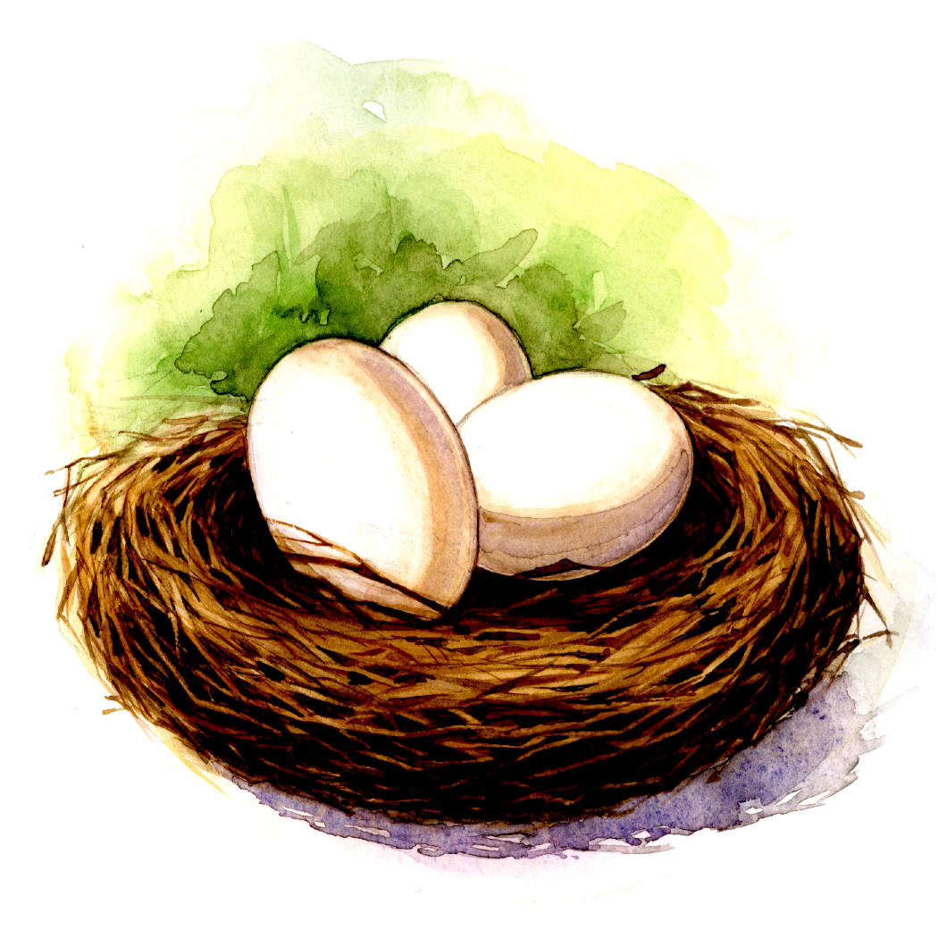

***Activity Station Two  
(Cost/Benefit page)***

**Benefit**

**Add 7 “meat units”**

**+** C:\Users\Booth\AppData\Local\Microsoft\Windows\Temporary Internet Files\Content.IE5\9U03IMF3\MC900264362[1].wmfC:\Users\Booth\AppData\Local\Microsoft\Windows\Temporary Internet Files\Content.IE5\9U03IMF3\MC900264362[1].wmfC:\Users\Booth\AppData\Local\Microsoft\Windows\Temporary Internet Files\Content.IE5\9U03IMF3\MC900264362[1].wmfC:\Users\Booth\AppData\Local\Microsoft\Windows\Temporary Internet Files\Content.IE5\9U03IMF3\MC900264362[1].wmfC:\Users\Booth\AppData\Local\Microsoft\Windows\Temporary Internet Files\Content.IE5\9U03IMF3\MC900264362[1].wmf

C:\Users\Booth\AppData\Local\Microsoft\Windows\Temporary Internet Files\Content.IE5\9U03IMF3\MC900264362[1].wmfC:\Users\Booth\AppData\Local\Microsoft\Windows\Temporary Internet Files\Content.IE5\9U03IMF3\MC900264362[1].wmf

***Activity Station Three  
(cover page)***

**Go to the local soda shop and order a Chocolate Malt and play your favorite song on the juke box**

**C:\Users\Booth\AppData\Local\Microsoft\Windows\Temporary Internet Files\Content.IE5\9U03IMF3\MC900089354[1].wmf C:\Users\Booth\AppData\Local\Microsoft\Windows\Temporary Internet Files\Content.IE5\0S1DL3O1\MC900083039[1].wmf**

***Activity Station Three  
(Cost/Benefit page)***

**COST**

**Subtract 1 “meat units” per person in group**

* C:\Users\Booth\AppData\Local\Microsoft\Windows\Temporary Internet Files\Content.IE5\9U03IMF3\MC900264362[1].wmf **(per person)**

***Activity Station Four  
(cover page)***

**Walk a friend home from school.**

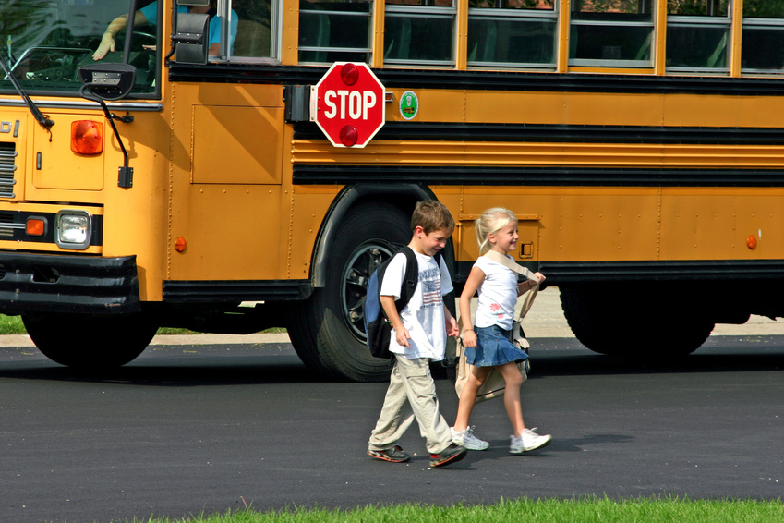

***Activity Station Four  
(Cost/Benefit page)***

**Benefit**

**Add 2 “meat units” per person in group**

**+** C:\Users\Booth\AppData\Local\Microsoft\Windows\Temporary Internet Files\Content.IE5\9U03IMF3\MC900264362[1].wmfC:\Users\Booth\AppData\Local\Microsoft\Windows\Temporary Internet Files\Content.IE5\9U03IMF3\MC900264362[1].wmf **(per person)**

***Activity Station Five  
(cover page)***

**Rake leaves for a next door neighbor.**

**C:\Users\Booth\AppData\Local\Microsoft\Windows\Temporary Internet Files\Content.IE5\9U03IMF3\MC900089450[1].wmf**

***Activity Station Five  
(Cost/Benefit page)***

**Benefit**

**Add 5 “meat units”**

**+**C:\Users\Booth\AppData\Local\Microsoft\Windows\Temporary Internet Files\Content.IE5\9U03IMF3\MC900264362[1].wmfC:\Users\Booth\AppData\Local\Microsoft\Windows\Temporary Internet Files\Content.IE5\9U03IMF3\MC900264362[1].wmf C:\Users\Booth\AppData\Local\Microsoft\Windows\Temporary Internet Files\Content.IE5\9U03IMF3\MC900264362[1].wmfC:\Users\Booth\AppData\Local\Microsoft\Windows\Temporary Internet Files\Content.IE5\9U03IMF3\MC900264362[1].wmfC:\Users\Booth\AppData\Local\Microsoft\Windows\Temporary Internet Files\Content.IE5\9U03IMF3\MC900264362[1].wmf

***Activity Station Six  
(cover page)***

**Play catch with your younger brother**



***Activity Station Six  
(Cost/Benefit page)***

**COST**

**Subtract 7 “meat units”**

**You threw a ball that broke your neighbor’s window. ☹**

* C:\Users\Booth\AppData\Local\Microsoft\Windows\Temporary Internet Files\Content.IE5\9U03IMF3\MC900264362[1].wmfC:\Users\Booth\AppData\Local\Microsoft\Windows\Temporary Internet Files\Content.IE5\9U03IMF3\MC900264362[1].wmfC:\Users\Booth\AppData\Local\Microsoft\Windows\Temporary Internet Files\Content.IE5\9U03IMF3\MC900264362[1].wmfC:\Users\Booth\AppData\Local\Microsoft\Windows\Temporary Internet Files\Content.IE5\9U03IMF3\MC900264362[1].wmfC:\Users\Booth\AppData\Local\Microsoft\Windows\Temporary Internet Files\Content.IE5\9U03IMF3\MC900264362[1].wmfC:\Users\Booth\AppData\Local\Microsoft\Windows\Temporary Internet Files\Content.IE5\9U03IMF3\MC900264362[1].wmfC:\Users\Booth\AppData\Local\Microsoft\Windows\Temporary Internet Files\Content.IE5\9U03IMF3\MC900264362[1].wmf

***Activity Station Seven  
(cover page)***

**Feed a friend’s fish while he is on vacation.**

**C:\Users\Booth\AppData\Local\Microsoft\Windows\Temporary Internet Files\Content.IE5\D9VA7QF0\MC900391432[1].wmf**

***Activity Station Seven  
(Cost/Benefit page)***

**Benefit**

**Add 6 “meat units”**

**+**C:\Users\Booth\AppData\Local\Microsoft\Windows\Temporary Internet Files\Content.IE5\9U03IMF3\MC900264362[1].wmfC:\Users\Booth\AppData\Local\Microsoft\Windows\Temporary Internet Files\Content.IE5\9U03IMF3\MC900264362[1].wmf C:\Users\Booth\AppData\Local\Microsoft\Windows\Temporary Internet Files\Content.IE5\9U03IMF3\MC900264362[1].wmfC:\Users\Booth\AppData\Local\Microsoft\Windows\Temporary Internet Files\Content.IE5\9U03IMF3\MC900264362[1].wmfC:\Users\Booth\AppData\Local\Microsoft\Windows\Temporary Internet Files\Content.IE5\9U03IMF3\MC900264362[1].wmfC:\Users\Booth\AppData\Local\Microsoft\Windows\Temporary Internet Files\Content.IE5\9U03IMF3\MC900264362[1].wmf

***Activity Station Eight  
(cover page)***

**Got a part time job at a local farm harvesting corn**



***Activity Station Eight  
(Cost/Benefit page)***

**Benefit**

**Add 3 “meat units” per person in group**

**+**C:\Users\Booth\AppData\Local\Microsoft\Windows\Temporary Internet Files\Content.IE5\9U03IMF3\MC900264362[1].wmfC:\Users\Booth\AppData\Local\Microsoft\Windows\Temporary Internet Files\Content.IE5\9U03IMF3\MC900264362[1].wmf C:\Users\Booth\AppData\Local\Microsoft\Windows\Temporary Internet Files\Content.IE5\9U03IMF3\MC900264362[1].wmf **(per person)**

***Activity Station Nine  
(cover page)***

**Took a short cut home after school and walked through the park.**

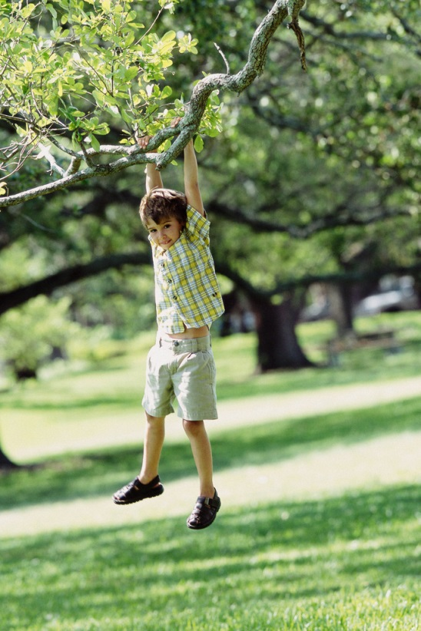

***Activity Station Nine  
(Cost/Benefit page)***

**COST**

**Subtract 3 “meat units”**

**You climbed a tree and tore your clothes. ☹**

* C:\Users\Booth\AppData\Local\Microsoft\Windows\Temporary Internet Files\Content.IE5\9U03IMF3\MC900264362[1].wmfC:\Users\Booth\AppData\Local\Microsoft\Windows\Temporary Internet Files\Content.IE5\9U03IMF3\MC900264362[1].wmfC:\Users\Booth\AppData\Local\Microsoft\Windows\Temporary Internet Files\Content.IE5\9U03IMF3\MC900264362[1].wmf

***Activity Station Ten  
(cover page)***

**Started your own car wash business**

**C:\Users\Booth\AppData\Local\Microsoft\Windows\Temporary Internet Files\Content.IE5\D9VA7QF0\MC900088994[1].wmf**

***Activity Station Ten  
(Cost/Benefit page)***

**Benefit**

**Add 4 “meat units” per person in group**

**+**C:\Users\Booth\AppData\Local\Microsoft\Windows\Temporary Internet Files\Content.IE5\9U03IMF3\MC900264362[1].wmfC:\Users\Booth\AppData\Local\Microsoft\Windows\Temporary Internet Files\Content.IE5\9U03IMF3\MC900264362[1].wmf C:\Users\Booth\AppData\Local\Microsoft\Windows\Temporary Internet Files\Content.IE5\9U03IMF3\MC900264362[1].wmfC:\Users\Booth\AppData\Local\Microsoft\Windows\Temporary Internet Files\Content.IE5\9U03IMF3\MC900264362[1].wmf

**(per person)**

**Simulation Cards**

|  |  |
| --- | --- |
| **Group One**  **Activity Amount**  **(*Beginning balance)*  10**  ***2. Gather eggs to take to the***  ***Farmer’s Market _____***  ***3. Go to the local soda shop and***  ***order a chocolate malt and play***  ***your favorite song on the juke box _____***  ***5. Rake leaves for a next door***  ***neighbor _____***  ***7. Feed a friend’s fish while he***  ***is on vacation _____***  ***9. Took a short cut home after***  ***school and walked through the***  ***park _____***  ***Ending total _______*** | **Group Two**  **Activity Amount**  ***(Beginning balance)*  10**  **1. Go to the drive-in movies**  **and watch a newly released**  **movie _____**  **4. Walk a friend home from**  **school _____**  **6. Play catch with your younger**  **brother _____**  **8. Got a part-time job at a local**  **farm harvesting corn _____**  **10. Started your own car was**  **business _____**    ***Ending total _______*** |
| **Group Three**  **Activity Amount**  **(*Beginning balance)*  10**  **1. Go to the drive-in movies**  **and watch a newly released**  **movie _____**  ***2. Gather eggs to take to the***  ***Farmer’s Market _____***  **6. Play catch with your younger**  **brother _____**  ***7. Feed a friend’s fish while he***  ***is on vacation _____***  **10. Started your own car was**  **business _____**  ***Ending total _______*** | **Group Four**  **Activity Amount**  **(*Beginning balance)*  10**  ***3. Go to the local soda shop and***  ***order a chocolate malt and play***  ***your favorite song on the juke box _____***  ***5. Rake Leaves for a next door***  ***neighbor _____***  **8. Got a part-time job at a local**  **farm harvesting corn _____**  ***9. Took a short cut home after***  ***school and walked through the***  ***park _____***  **10. Started your own car was**  **business _____**  ***Ending total _______*** |

**Simulation Cards**

|  |  |
| --- | --- |
| **Group Five**  **Activity Amount**  **(*Beginning balance)*  10**  ***2. Gather eggs to take to the***  ***Farmer’s Market _____***  ***5. Rake Leaves for a next door***  ***neighbor _____***  **6. Play catch with your younger**  **brother _____**  **8. Got a part-time job at a local**  **farm harvesting corn _____**  ***9. Took a short cut home after***  ***school and walked through the***  ***park _____***  ***Ending total _______*** | **Group Six**  **Activity Amount**  **(*Beginning balance)*  10**  **1. Go to the drive-in movies**  **and watch a newly released**  **movie _____**  ***3. Go to the local soda shop and***  ***order a chocolate malt and play***  ***your favorite song on the juke box _____***  **4. Walk a friend home from**  **school _____**  ***5. Rake leaves for a next door***  ***neighbor _____***  ***7. Feed a friend’s fish while he***  ***is on vacation _____***  ***Ending total _______*** |
| **Group Seven**  **Activity Amount**  **(*Beginning balance)*  10**  **4. Walk a friend home from**  **school _____**  **6. Play catch with your younger**  **brother _____**  ***7. Feed a friend’s fish while he***  ***is on vacation _____***  **8. Got a part-time job at a local**  **farm harvesting corn _____**  **10. Started your own car was**  **business _____**  ***Ending total _______*** | **Group Eight**  **Activity Amount**  **(*Beginning balance)*  10**  ***2. Gather eggs to take to the***  ***Farmer’s Market _____***  **4. Walk a friend home from**  **school _____**  **6. Play catch with your younger**  **brother _____**  **8. Got a part-time job at a local**  **farm harvesting corn _____**  **10. Started your own car was**  **business _____**  ***Ending total _______*** |

**Simulation Cards**

|  |  |
| --- | --- |
| **Group Nine**  **Activity Amount**  **(*Beginning balance)*  10**  **1. Go to the drive-in movies**  **and watch a newly released**  **movie _____**  ***3. Go to the local soda shop and***  ***order a chocolate malt and play***  ***your favorite song on the juke box _____***  ***5. Rake leaves for a next door***  ***neighbor _____***  ***7. Feed a friend’s fish while he***  ***is on vacation _____***  ***9. Took a short cut home after***  ***school and walked through the***  ***park _____***  ***Ending total _______*** | **Group Ten**  **Activity Amount**  **(*Beginning balance)*  10**  ***3. Go to the local soda shop and***  ***order a chocolate malt and play***  ***your favorite song on the juke box _____***  **4. Walk a friend home from**  **school _____**  ***5. Rake leaves for a next door***  ***neighbor _____***  **6. Play catch with your younger**  **brother _____**  **8. Got a part-time job at a local**  **farm harvesting corn _____**  ***Ending total _______*** |

**C:\Users\Booth\AppData\Local\Microsoft\Windows\Temporary Internet Files\Content.IE5\D9VA7QF0\MC910217208[1].wmfC:\Users\Booth\AppData\Local\Microsoft\Windows\Temporary Internet Files\Content.IE5\D9VA7QF0\MC910217208[1].wmf***Visual Three  
Simulation Debrief*

**Cost/Benefit Analysis - A process of examining the advantages (benefits) and disadvantages (costs) of each available alternative in arriving at a decision.**

**Choice - Decision made or course of action taken after examining the benefits and costs of the decision. The decision had greater benefits than costs.**

**Consequences - A result or effect of an action or decision; may be positive or negative.**

**Unintended Consequence - The unexpected and unplanned results of a decision or action.**

**Name: ___________________________________ Date: ________________________**

**Assessment – Cost/Benefit Analysis**

**Scenario:** This summer, you have an opportunity to travel to your cousin’s home which is located in another state. During the two week stay, you and your cousin will participate in a volunteer program at the local hospital where your uncle works. Your parents are involving you in the decision making process. In the chart below, list below the costs and benefits of this opportunity. After evaluating the costs and benefits, make your choice. List your choice and tell why you made the decision in the space provided at the bottom.

|  |  |
| --- | --- |
| **Costs** | **Benefits** |
|  |  |

Your Choice: ________________________________________________________________________________________________________________________________________________________________________________________________________________________________________________________________________________________________________________________